# Final Report: Secure Cloud Native Computing - Container Orchestration

**Student Name:** Valentyn Tokariuk  
**Student ID:** GA747482  
**Course Code:** CIS3111  
**Academic Year:** 2023/24

Final Report: Secure Cloud Native Computing - Container Orchestration 1

1. Introduction 1

2. Task 1: Current Deployment 1

2.1 Docker Deployment 1

2.2 API Implementation and Testing 2

3. Task 2: Kubernetes Deployment 4

3.1 Minikube and Docker Setup 4

3.2 Kubernetes Resources Configuration 4

3.3 Deployment and Service Management 4

3.4 Testing and Monitoring 4

4. Task 3: Secured Deployment 5

4.1 Gateway Functionality for Security (not implemented yet) 5

4.2 Access Restrictions via API Gateway (not implemented yet) 6

5. Conclusion 6

6. References 7

7. Code snippets 8

## 1. Introduction

The primary objective is to demonstrate a comprehensive understanding and application of container orchestration technologies using Docker and Kubernetes. Container orchestration is critical in deploying, managing, and scaling cloud-native applications efficiently, ensuring these applications are both resilient and responsive to dynamic cloud environments.

The project simulates a real-world scenario where an online university course enrollment service, previously hosted on standalone servers, is transitioned to a containerized setup aimed at improving scalability, reliability, and security. This involves migrating an existing Docker deployment into a managed Kubernetes environment.

Through this assignment, we explored various components of Kubernetes, including ConfigMaps, Secrets, Deployments, and Services, alongside the development and deployment of an API using FastAPI.

This report will walk through each task, detailing the procedures performed, challenges encountered, and insights gained from deploying a complex service-oriented architecture in a Kubernetes environment.

## 2. Task 1: Current Deployment

### 2.1 Docker Deployment

The initial deployment of the Enrollments application involved setting up two primary Docker containers: one for the application itself and another for the PostgreSQL database. This setup was designed to replicate a typical microservices architecture where each service is isolated in its own container, ensuring independent scalability and management.

**Container Setup for PostgreSQL Database:**

* **Image Used**: **postgres:latest**
* **Environment Variables**:
  + **POSTGRES_DB**: Set to "universitydb" to specify the database used by the application.
  + **POSTGRES_USER**: Configured as "postgres", which is the default administrative user.
  + **POSTGRES_PASSWORD**: The password is managed securely through Docker secrets to prevent exposure in the configuration files.
* **Network Settings**: Attached to a custom Docker network (**university-net**), facilitating isolated communication with the Enrollments application container.

**Container Setup for Enrollments Application:**

* **Image Used**: **markvellaum/university:v0.0.1**
* **Environment Variables**:
  + **PGHOST**: Points to the PostgreSQL service within the Docker network, ensuring the application can connect to the database.
  + **PGPORT**, **PGUSER**, **PGPASS**, **PGDB**: Configured to match the PostgreSQL database settings for seamless connectivity.
* **Network Settings**: Shares the **university-net** Docker network with the PostgreSQL container to enable secure internal communications without exposing database transactions to the external network.

**Deployment Process:**

* A Docker compose script or equivalent deployment command sequence was used to launch these containers, ensuring that they start in the correct order—database first, followed by the application.
* The use of Docker volumes was also integrated to ensure data persistence beyond the lifecycle of individual containers, particularly for the database.

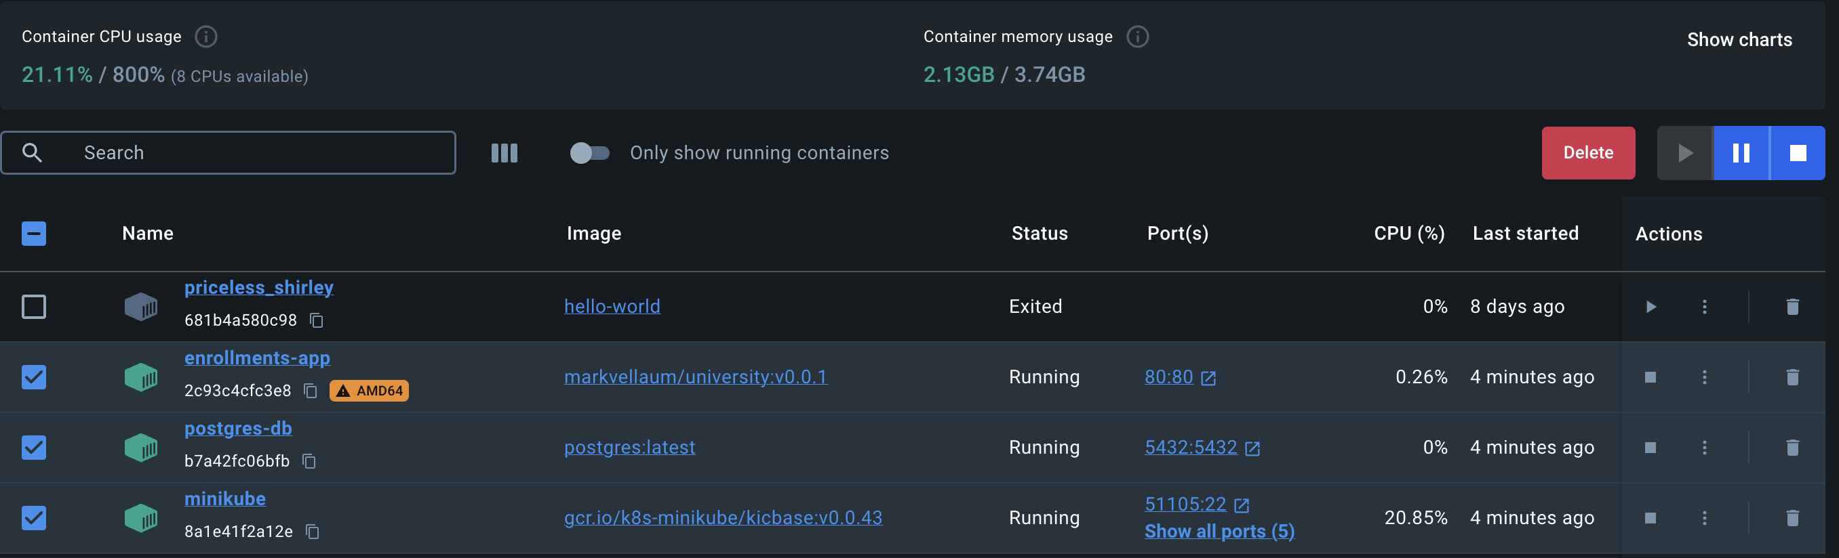

Figure 1 – Docker containers running

### 2.2 API Implementation and Testing

The API for the Enrollments application was developed using FastAPI, a modern, fast (high-performance), web framework for building APIs with Python 3.7+ based on standard Python type hints. The key functionalities provided by this API include managing courses, students, and the enrollment processes.

**API Features**:

* **Courses Management**: Allows users to add, update, and delete course information.
* **Students Management**: Facilitates the addition, updating, and removal of student records.
* **Enrollment Process**: Enables the enrollment of students into specified courses, managing many-to-many relationships between students and courses.

**FastAPI Integration**:

* FastAPI was chosen for its automatic interactive API documentation (using Swagger UI) and its dependency injection system, which simplifies security implementations and database connections.
* The API routes were designed to be RESTful, ensuring that they are intuitive and resource-oriented, which simplifies the front-end development for consuming these APIs.

**Testing with Swagger UI**:

* Swagger UI was integrated into the FastAPI setup, providing an interactive API documentation interface where developers can easily test the API endpoints.
* This setup not only helped in verifying the correct implementation of the API functionalities but also served as a practical tool during development for immediate feedback and troubleshooting.

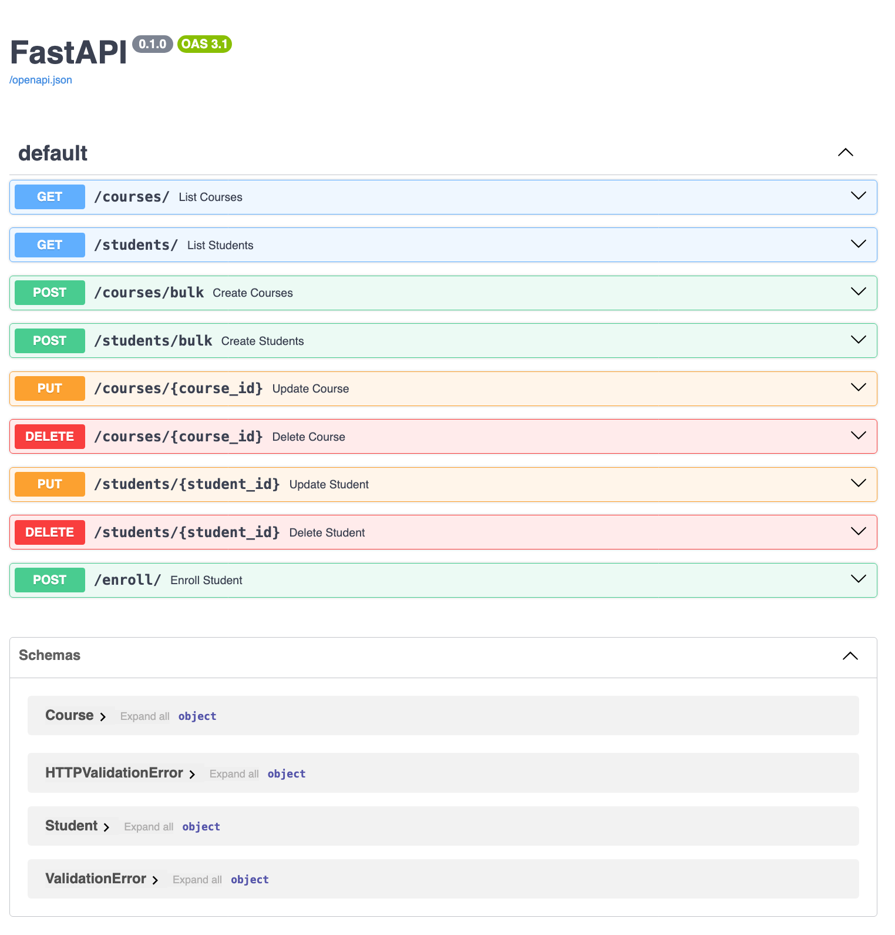

Figure 2 - Swagger UI Page

This comprehensive setup with Docker for deployment and FastAPI for API management ensured that the Enrollments application was not only functional but also ready for further integration into more complex orchestration scenarios, such as Kubernetes, which is discussed in the subsequent section of this report.

## 3. Task 2: Kubernetes Deployment

### 3.1 Minikube and Docker Setup

To transition the Enrollments application from a standalone Docker environment to a managed Kubernetes cluster, I utilized Minikube

**Steps to Set Up Minikube and Configure Docker:**

1. **Installation of Minikube**: Minikube was installed on the local machine using the official [Minikube installation guide](https://minikube.sigs.k8s.io/docs/start/). This included downloading the latest Minikube binary and integrating it with the system.
2. **Starting Minikube**:

minikube start

This command initializes a single-node Kubernetes cluster running inside a Virtual Machine (VM) on the local machine.

1. **Configuring Docker to Use Minikube’s Docker Daemon**:

eval $(minikube docker-env)

This command configures the shell environment to use Minikube's Docker daemon instead of the local Docker daemon. This step ensures that all Docker commands and Kubernetes pods use the same Docker instance, which simplifies container management and reduces resource overhead.

### 3.2 Kubernetes Resources Configuration

Configuring Kubernetes resources involved defining several YAML files that describe the desired state of the system, including ConfigMaps, Secrets, Persistent Volumes (PVs), Persistent Volume Claims (PVCs), Deployments, and Services.

**Key Configurations**:

* **ConfigMap** (**app-config.yaml**):
* **Secret** (**db-credentials.yaml**):
* **Persistent Volume and Claim** (**postgres-pv.yaml** and **postgres-pvc.yaml**):
* **Deployment** (**enrollments-deployment.yaml**):

### 3.3 Deployment and Service Management

Deployment management involved applying the Kubernetes configurations using **kubectl** commands to create and manage the lifecycle of all Kubernetes objects.

* **Applying Configurations**:

kubectl apply -f app-config.yaml kubectl apply -f db-credentials.yaml kubectl apply -f postgres- pv.yaml

kubectl apply -f postgres-pvc.yaml kubectl apply -f enrollments-deployment.yaml

* **Service Setup** (**enrollments-service.yaml**):

This service configuration exposes the Enrollments application outside of the Kubernetes cluster, making it accessible via a specific port on the Minikube node.

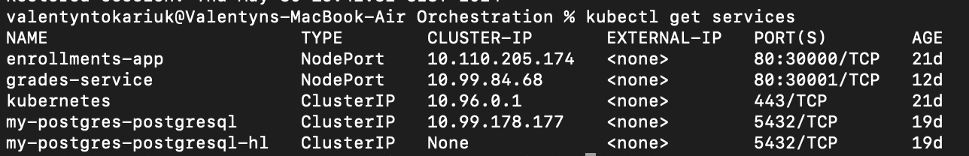

Figure 3 - kubectl get services

### 3.4 Testing and Monitoring

For testing the deployment, we ensured that all resources were correctly provisioned and operational within the Kubernetes cluster. Monitoring tools such as the Kubernetes Dashboard and command-line outputs from **kubectl get pods**, **kubectl describe pods** were extensively used to observe the status and health of the services.

* **Minikube Dashboard**:

minikube dashboard

This command launches a web-based Kubernetes dashboard that provides a detailed visual overview of cluster operations, allowing for real-time monitoring and troubleshooting.

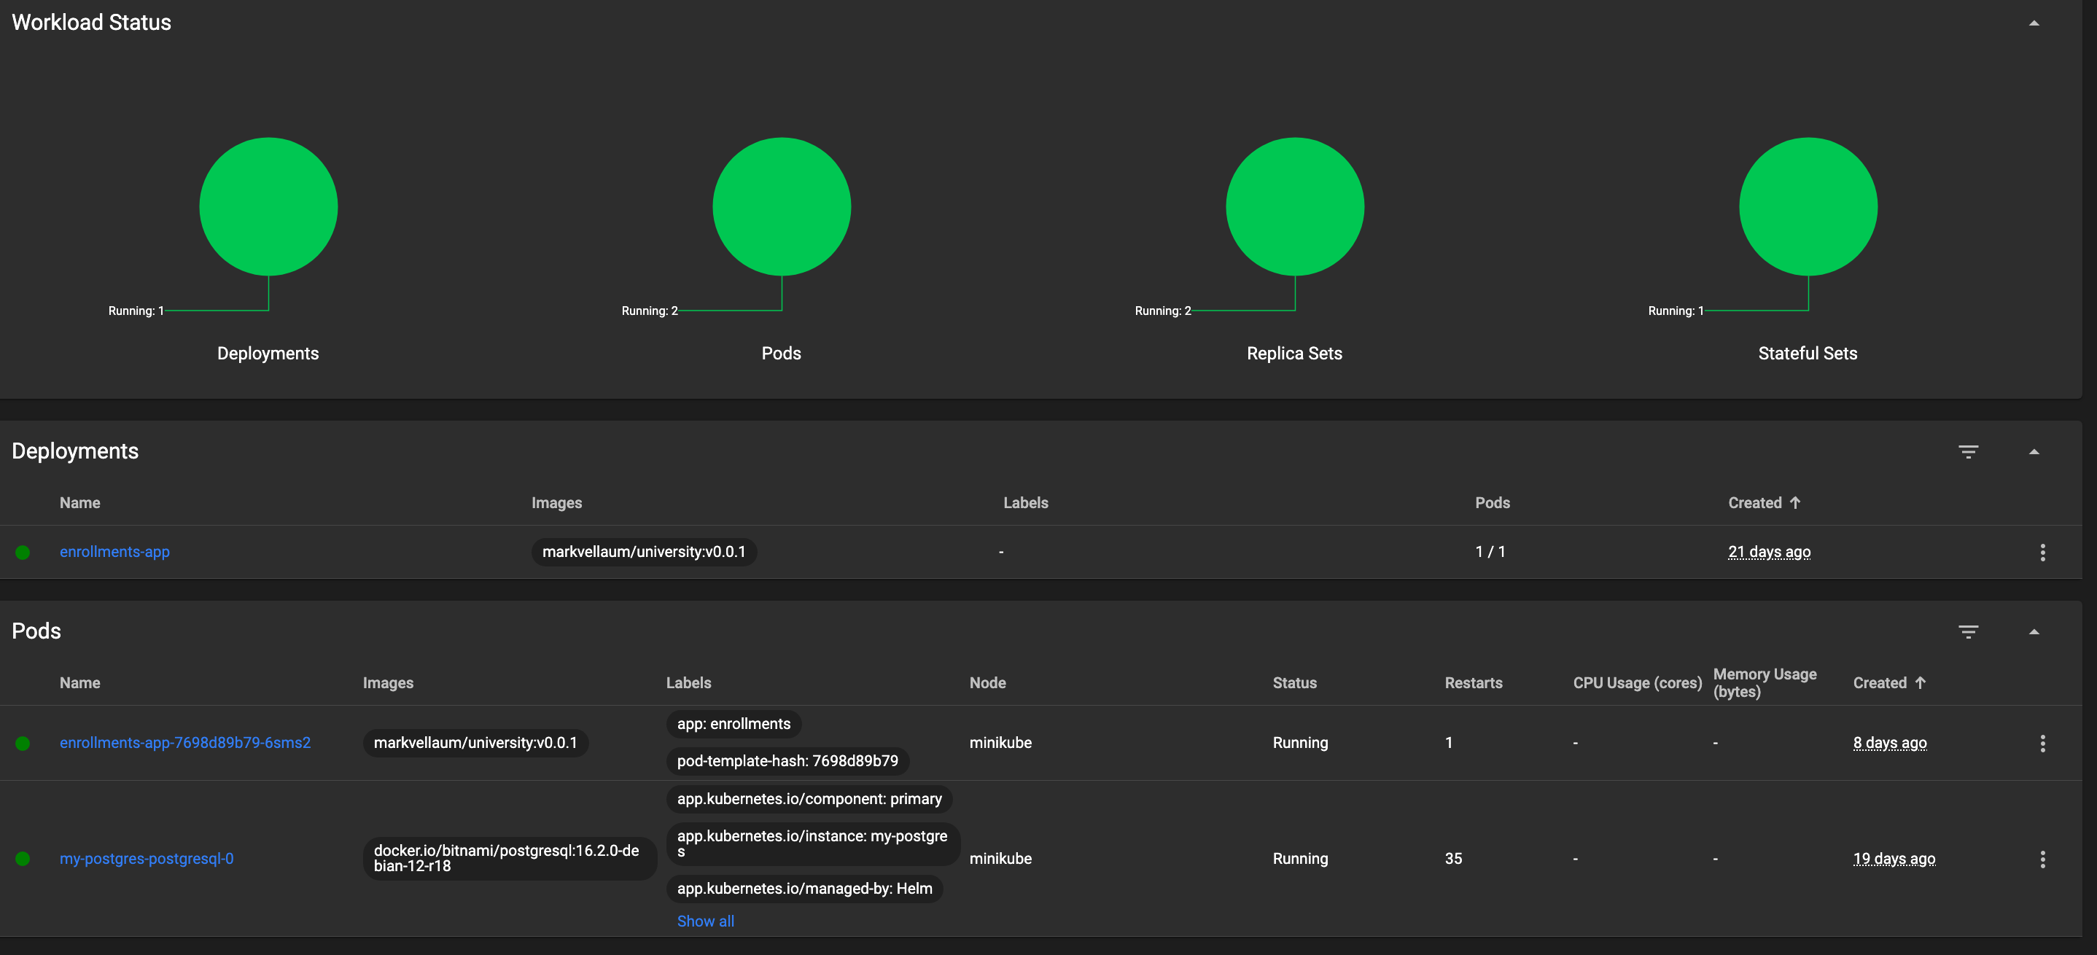

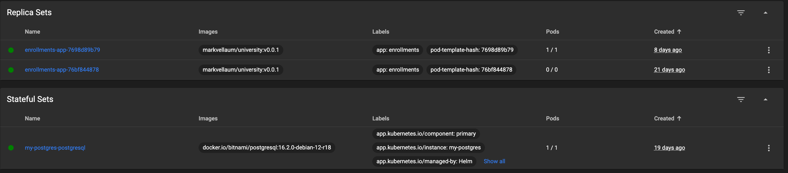

This comprehensive approach ensured that the Enrollments application was successfully transitioned into a robust Kubernetes environment, demonstrating the effective orchestration of containerized applications in a simulated cloud-native setting.

## 4. Task 3: Secured Deployment

As part of the migration to a managed Kubernetes platform in a cloud environment, securing communications within the cluster is paramount. Implementing a security API gateway is a critical component of this strategy. This section outlines the functionalities needed for an API gateway to protect the application effectively and manage access precisely.

### 4.1 Gateway Functionality for Security (not implemented yet)

**Objective**: Secure the cluster from Internet traffic sniffing and web service spoofing.

**Functionality Needed**:

1. **Encryption of Data in Transit**:
   * **SSL/TLS Termination**: The API gateway should handle SSL/TLS termination for all incoming traffic. This means decrypting incoming SSL/TLS traffic at the gateway before passing it to the backend services. This setup centralizes encryption management at the gateway, enhancing security by ensuring encrypted communications within the external network.
   * **Benefits**: Protects against eavesdropping and man-in-the-middle attacks where attackers might sniff unencrypted traffic.
2. **Service Authentication and Authorization**:
   * **Mutual TLS (mTLS)**: Implement mTLS to authenticate communication between services. The gateway ensures that both the client and server authenticate each other with valid certificates before establishing a connection.
   * **Benefits**: This prevents unauthorized access and ensures that communications can only be established with validated services, reducing the risk of spoofing by impostor back-ends.
3. **API Rate Limiting and Traffic Control**:
   * **Rate Limiting**: To safeguard against denial-of-service (DoS) attacks or traffic spikes that can lead to service disruption, the gateway should implement rate limiting.
   * **Traffic Shaping**: Controls the flow of traffic to services based on predefined rules, which can prioritize or block requests according to their source, type, or content.
   * **Benefits**: Enhances the overall resilience of the backend services by preventing them from being overwhelmed by high volumes of requests.

### 4.2 Access Restrictions via API Gateway (not implemented yet)

**Objective**: Manage access to sensitive endpoints, ensuring only authorized access to specific functionalities within the Enrollments and Grades applications.

**Functionality Needed**:

1. **Role-Based Access Control (RBAC)**:
   * **Endpoint-Level Permissions**: Implement RBAC within the API gateway to control access based on the user’s role. Configure the gateway to recognize different roles (e.g., admin, student) and enforce access policies accordingly.
   * **Benefits**: Ensures that only authorized personnel can manage courses, students, and enrollments, while students can only access their specific grades.
2. **Attribute-Based Access Control (ABAC)**:
   * **Dynamic Access Control**: Utilize ABAC to fine-tune access permissions based on the attributes of the user and the requested resources. For instance, a student can be restricted to access only their grades and not the grades of other students.
   * **Benefits**: Provides a more granular level of access control, enhancing the security and privacy of the data.
3. **Secure Token Service (STS)**:
   * **JWT Tokens for Sessions**: Use JSON Web Tokens (JWT) to manage sessions. The gateway issues a JWT upon successful authentication, which must be presented in subsequent requests to access protected resources.
   * **Token Validation**: The gateway validates the token to ensure it’s not expired and checks the token's permissions before allowing access to a resource.
   * **Benefits**: Streamlines the authentication and authorization process, reducing the overhead on backend services and enhancing security by limiting token lifespan and scope.

**Implementation Considerations**:

* **Integration with Identity Providers (IdPs)**: The gateway should integrate seamlessly with external IdPs (e.g., OAuth2, OpenID Connect providers) for managing user identities and authentication.
* **Audit and Monitoring**: Implement comprehensive logging and monitoring of all requests that pass through the gateway to ensure traceability and to detect potential security breaches or anomalies.

## 5. Conclusion

This project provided a comprehensive exploration into the deployment and management of a cloud-native application using Docker and Kubernetes. Through the course of this assignment, I transitioned an online university course enrollment service from a standalone Docker setup to a fully managed Kubernetes environment. This process highlighted the advantages of container orchestration in enhancing scalability, reliability, and security of web applications.

**Future Work and Improvements**:

1. **Security Enhancements**: Going forward, the implementation of a security API gateway using solutions like Istio will be a priority. This will allow for sophisticated traffic management, secure service-to-service communication, and fine-grained access control policies.
2. **Auto-Scaling Capabilities**: Integrating Kubernetes Horizontal Pod Autoscaler (HPA) would automate the scaling of application pods based on observed CPU usage or other select metrics, thus improving resource efficiency.
3. **CI/CD Integration**: Establishing a continuous integration and continuous deployment pipeline would streamline updates and new releases to the application, ensuring that changes are automatically tested and deployed without downtime.
4. **Performance Monitoring**: Incorporating more comprehensive monitoring and logging tools such as Prometheus and Grafana to track the performance and health of the application in real-time. This would provide insights into optimization and proactive management of potential issues.

## 6. References

**Tools Used:**

* **Docker**: Software platform for building, testing, and deploying applications quickly.
* **Kubernetes**: Open-source system for automating deployment, scaling, and management of containerized applications.
* **Minikube**: Tool that lets you run Kubernetes locally.
* **Helm**: Package manager for Kubernetes.
* **FastAPI**: Modern, fast web framework for building APIs with Python 3.7+ based on standard Python type hints.
* **PostgreSQL**: Open source object-relational database system.

**Documentation and Online Resources:**

1. **Docker Documentation**  
   Docker Inc. "Docker Documentation." Accessed [specific date]. Available: <https://docs.docker.com/>
2. **Kubernetes Documentation**  
   Kubernetes. "Kubernetes Documentation." Accessed [specific date]. Available: <https://kubernetes.io/docs/>
3. **Minikube Documentation**  
   Kubernetes. "Minikube." Accessed [specific date]. Available: <https://minikube.sigs.k8s.io/docs/start/>
4. **Helm Documentation**  
   Helm. "Helm Docs." Accessed [specific date]. Available: <https://helm.sh/docs/>
5. **FastAPI Documentation**  
   Tiangolo. "FastAPI." Accessed [specific date]. Available: https://fastapi.tiangolo.com/
6. **PostgreSQL Documentation**  
   PostgreSQL. "PostgreSQL Documentation." Accessed [specific date]. Available: <https://www.postgresql.org/docs/>

**Security Implementation References:**

1. **Istio Security**  
   Istio Authors. "Istio Security.".

Available: https://istio.io/latest/docs/concepts/security/

1. **OAuth 2.0 and OpenID Connect**  
   Hardt, D. (2012). "The OAuth 2.0 Authorization Framework." RFC 6749. Available: <https://tools.ietf.org/html/rfc6749>
2. Sakimura, N., et al. (2014). "OpenID Connect Core 1.0." Available: https://openid.net/specs/openid-connect-core-1_0.html

## Code snippets

##### **app-config.yaml**

apiVersion: v1

kind: ConfigMap

metadata:

name: enrollments-config

data:

app_port: "80"

**Explanation:** This **ConfigMap** stores configuration data that can be used by pods. **app_port** is set to "80", indicating the port on which the applications should listen.

##### **configmap.yaml**

apiVersion: v1

kind: ConfigMap

metadata:

name: enrollments-config

data:

app_port: "80"

database_hostname: "postgres-db"

database_password: "password"

database_user: "user"

database_name: "enrollmentdb"

database_port: "5432"

**Explanation:** This file extends **app-config.yaml** by including database credentials and connection details, used by applications to connect to the database.

##### **db-credentials.yaml**

apiVersion: v1

kind: Secret

metadata:

name: postgres-secret

type: Opaque

data:

postgres-password: cGFzcw== # Base64 encoded password

**Explanation:** This **Secret** object stores sensitive information such as the database password, securely encoding it in Base64. It prevents plaintext password exposure.

##### **deployment.yaml**

apiVersion: apps/v1

kind: Deployment

metadata:

name: enrollments-deployment

spec:

replicas: 2 # Increase the number of replicas for redundancy and load handling

selector:

matchLabels:

app: enrollments

template:

metadata:

labels:

app: enrollments

spec:

containers:

- name: enrollments

image: markvellaum/university:v0.0.1

ports:

- containerPort: 80

envFrom:

- configMapRef:

name: enrollments-config

**Explanation:** This **Deployment** configures the Enrollments application to run with 2 replicas for high availability and load distribution. It uses the image **markvellaum/university:v0.0.1** and configures environment variables from the **enrollments-config** ConfigMap.

##### **enrollments-deployment.yaml**

apiVersion: apps/v1

kind: Deployment

metadata:

name: enrollments-app

spec:

replicas: 1

selector:

matchLabels:

app: enrollments

template:

metadata:

labels:

app: enrollments

spec:

containers:

- name: enrollments

image: markvellaum/university:v0.0.1

ports:

- containerPort: 80

env:

- name: PGHOST

value: my-postgres-postgresql.default.svc.cluster.local

- name: PGPORT

value: "5432"

- name: PGUSER

value: "postgres"

- name: PGPASS

valueFrom:

secretKeyRef:

name: postgres-secret

key: postgres-password

- name: PGDB

value: "universitydb"

**Explanation:** Similar to **deployment.yaml**, but this deployment specifies explicit environment variables for the database connection, linking to the **postgres-secret** for sensitive data.

##### **enrollments-service.yaml**

apiVersion: v1

kind: Service

metadata:

name: enrollments-app

spec:

type: NodePort

ports:

- port: 80

targetPort: 80

nodePort: 30000

protocol: TCP

selector:

app: enrollments

**Explanation:** This **Service** defines how to access the Enrollments app externally. It maps port 30000 on each node to port 80 of the app, allowing external traffic.

##### **postgres-pv.yaml**

apiVersion: v1

kind: PersistentVolume

metadata:

name: postgres-pv

spec:

capacity:

storage: 5Gi

accessModes:

- ReadWriteOnce

persistentVolumeReclaimPolicy: Retain

storageClassName: standard

hostPath:

path: "/mnt/data"

Explanation: This PersistentVolume (PV) provides storage resources for the database. It is configured to retain data and provide 5Gi of storage.

postgres-pvc.yaml

apiVersion: v1

kind: PersistentVolumeClaim

metadata:

name: postgres-pvc

spec:

accessModes:

- ReadWriteOnce

resources:

requests:

storage: 5Gi

storageClassName: standard

**Explanation:** This **PersistentVolumeClaim** (PVC) requests storage from the PV. It ensures the database has storage available up to 5Gi.

##### **deploy.py**

import docker

client = docker.from_env()

# Define container names

postgres_container_name = 'postgres-db'

# Check if the container already exists

existing_containers = client.containers.list(all=True)

for container in existing_containers:

if container.name == postgres_container_name:

print(f"Stopping and removing existing container: {postgres_container_name}")

container.stop()

container.remove()

# Now, create the containers

print("Creating new PostgreSQL container")

postgres_container = client.containers.run(

'postgres:latest',

name=postgres_container_name,

network='university-net',

environment={

'POSTGRES_DB': 'universitydb',

'POSTGRES_USER': 'postgres',

'POSTGRES_PASSWORD': 'pass'

},

ports={'5432/tcp': 5432},

detach=True

)

print("Containers running:")

for container in client.containers.list():

print(container.name)

**Explanation:** This Python script uses the Docker API to manage Docker containers programmatically. It ensures that an old PostgreSQL container is removed before deploying a new one with specified configurations.

These explanations provide a clear understanding of each file's purpose and how they collectively support the deployment and operation of your application infrastructure.

##### **kube_deploy.sh**

#/bin/bash -c "$(curl -fsSL https://raw.githubusercontent.com/Homebrew/install/HEAD/install.sh)"

# Ensure Docker Desktop is started - Check Docker Desktop status on macOS

open -a Docker

# Wait for Docker to start

while ! docker system info > /dev/null 2>&1; do

echo "Waiting for Docker to start..."

sleep 1

done

echo "Docker is running."

# Start Minikube

echo "Starting Minikube..."

minikube start

# Set Docker environment to use Minikube's Docker daemon

echo "Setting Docker environment to use Minikube's..."

eval $(minikube docker-env)

# Build Docker images locally

echo "Building Docker images..."

docker build -t markvellaum/university:v0.0.1 -f Dockerfile .

docker pull postgres:latest

# Enable Kubernetes dashboard

echo "Enabling Kubernetes dashboard..."

minikube dashboard &

# Apply Kubernetes configurations

echo "Deploying Kubernetes configurations..."

kubectl apply -f app-config.yaml

kubectl apply -f db-credentials.yaml

kubectl apply -f postgres-pv.yaml

kubectl apply -f postgres-pvc.yaml

kubectl apply -f enrollments-deployment.yaml

kubectl apply -f enrollments-service.yaml

# Include grades app if needed

# kubectl apply -f grades-deployment.yaml

# kubectl apply -f grades-service.yaml

# Run the deploy.py script to start Docker containers

echo "Running deploy.py to start Docker containers..."

python3 deploy.py

# Check if Docker containers are running

echo "Checking Docker containers..."

docker ps

# Get the URL to access the enrollments-app service

echo "Getting URL to access the enrollments-app service..."

minikube service enrollments-app --url

# Output the URL for accessing the FastAPI documentation

enrollments_url=$(minikube service enrollments-app --url)

echo "Access your application at: $enrollments_url/docs"

echo "Deployments and services applied and running."

cat kube_deploy.sh

valentyntokariuk@Valentyns-MacBook-Air Orchestration % >....

python3 deploy.py

# Check if Docker containers are running

echo "Checking Docker containers..."

docker ps

# Get the URL to access the enrollments-app service

echo "Getting URL to access the enrollments-app service..."

minikube service enrollments-app --url

# Output the URL for accessing the FastAPI documentation

enrollments_url=$(minikube service enrollments-app --url)

echo "Access your application at: $enrollments_url/docs"

echo "Deployments and services applied and running."

cat kube_deploy.sh

dquote> >....

python3 deploy.py

# Check if Docker containers are running

echo "Checking Docker containers..."

docker ps

# Get the URL to access the enrollments-app service

echo "Getting URL to access the enrollments-app service..."

minikube service enrollments-app --url

# Output the URL for accessing the FastAPI documentation

enrollments_url=$(minikube service enrollments-app --url)

echo "Access your application at: $enrollments_url/docs"

echo "Deployments and services applied and running."

**Explanation:**

The kube_deploy.sh script provided is an automated bash script designed to streamline the setup and deployment process for a Kubernetes environment using Minikube and Docker.